38.55: a) Plot: Below is the graph of frequency versus stopping potential.

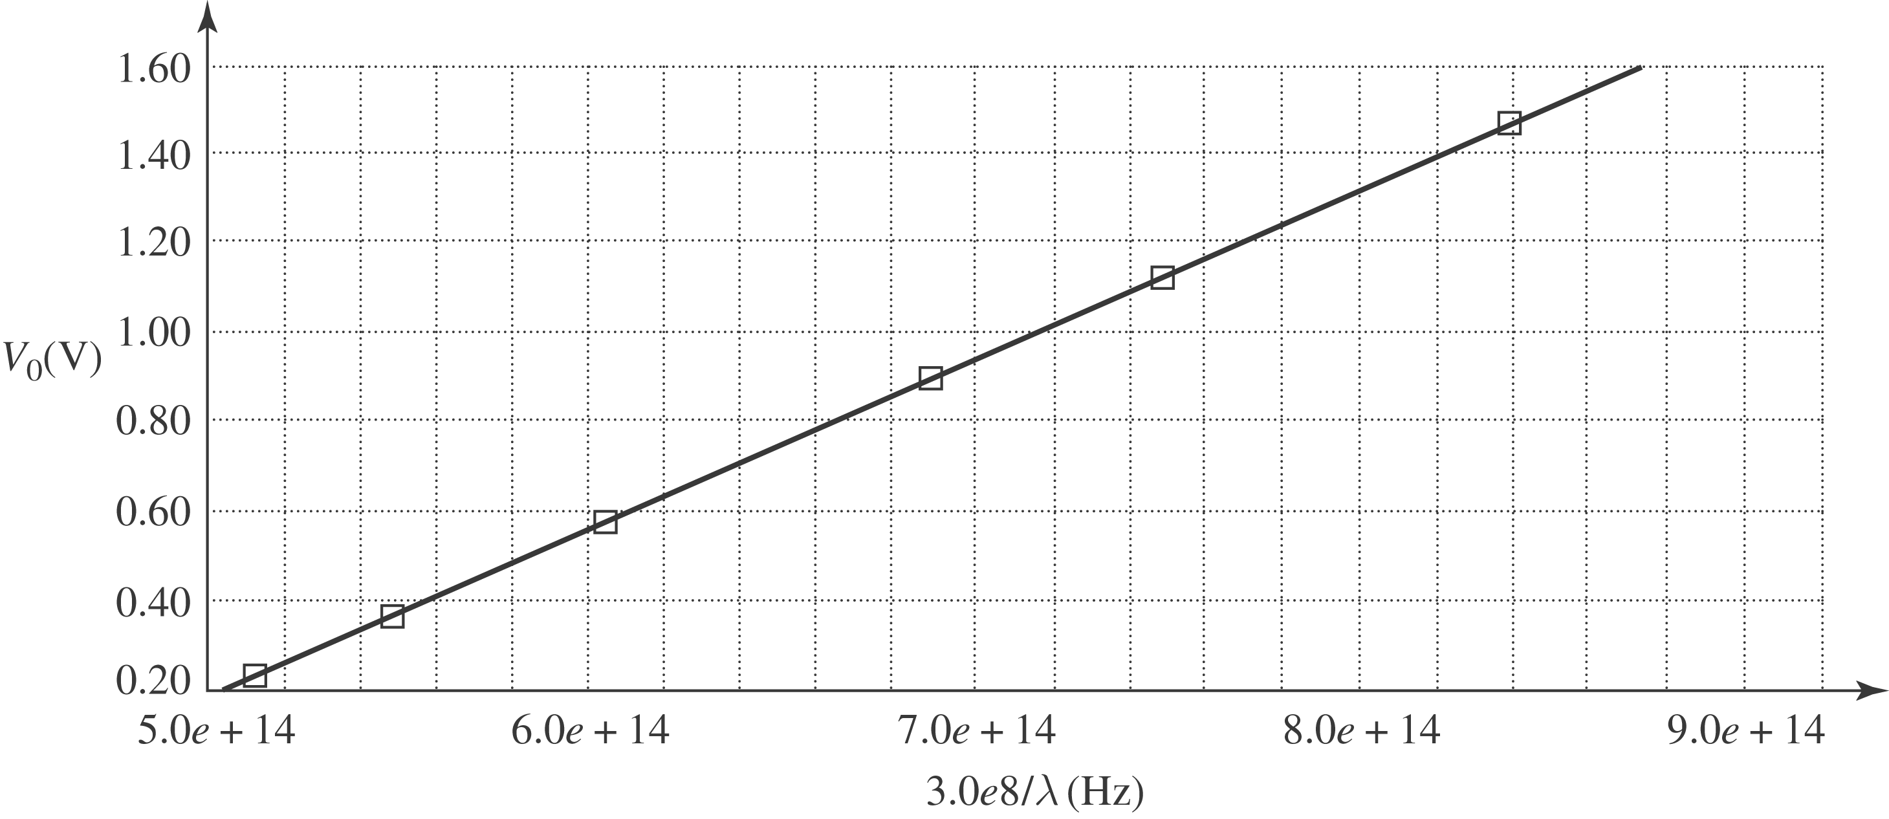

Threshold frequency is when the stopping potential is zero.
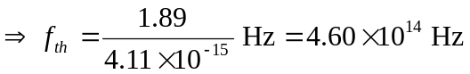
b) Threshold wavelength is 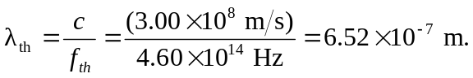
c) The work function is just
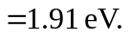
d) The slope of the graph is 